**Name: Jingjing Tan**

**Student id:19548**

**Lab Assignment #2**

1.Analyze **ALL** source codes for linked list operations in file *“Linked List Examples -2.zip”* by drawing diagrams through concrete examples

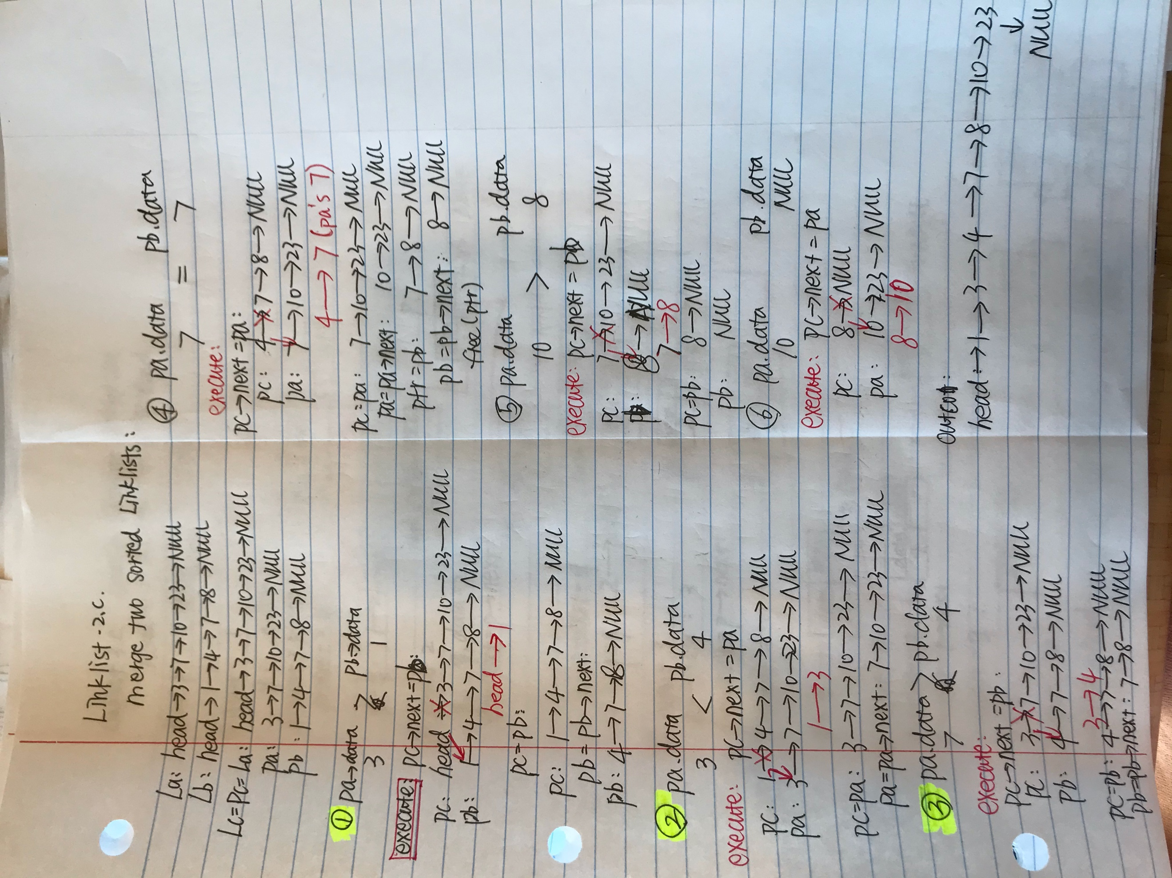

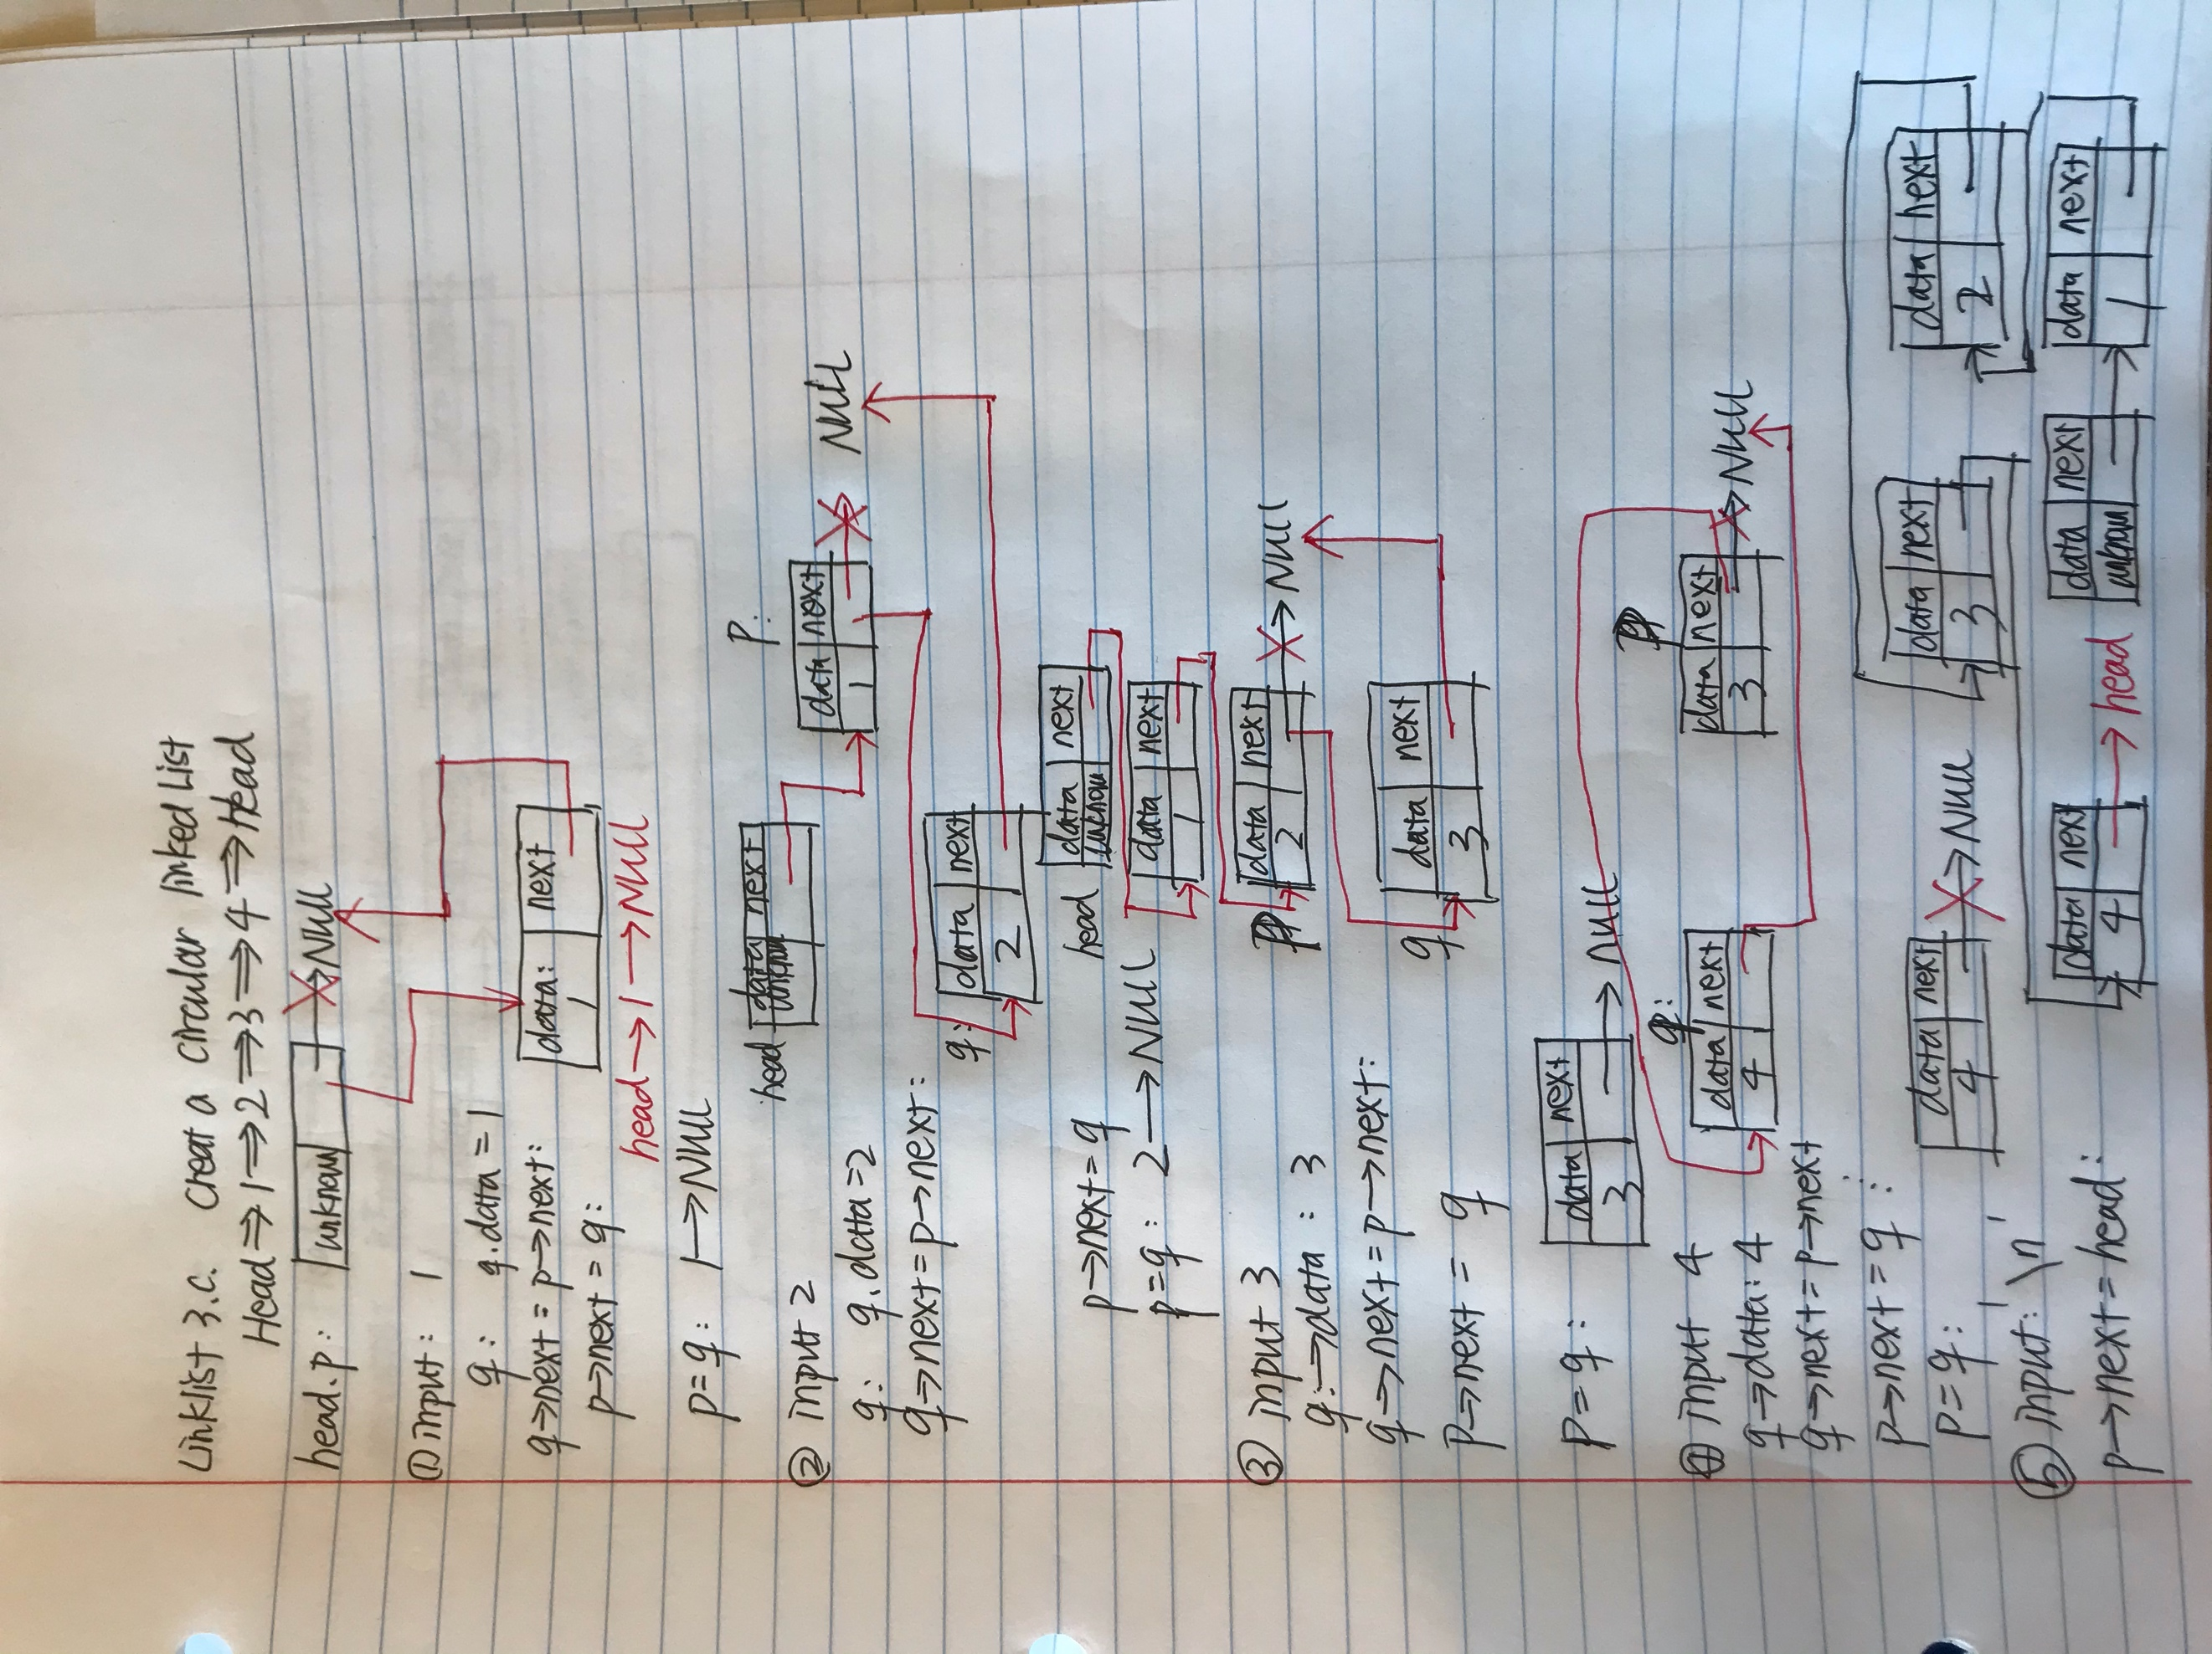

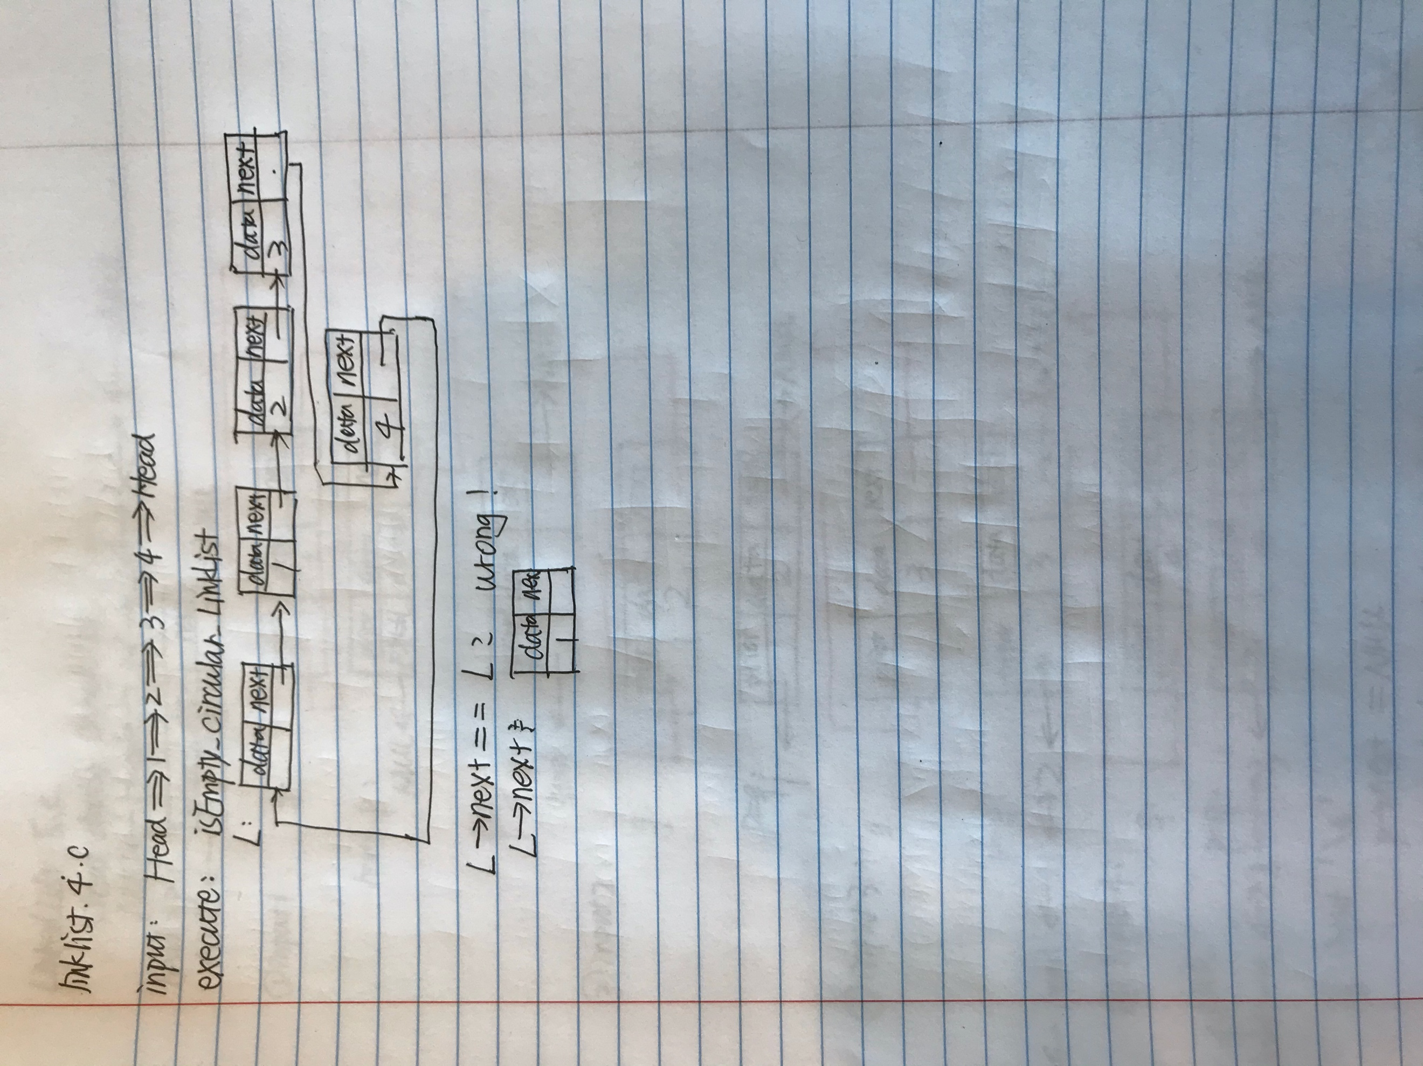

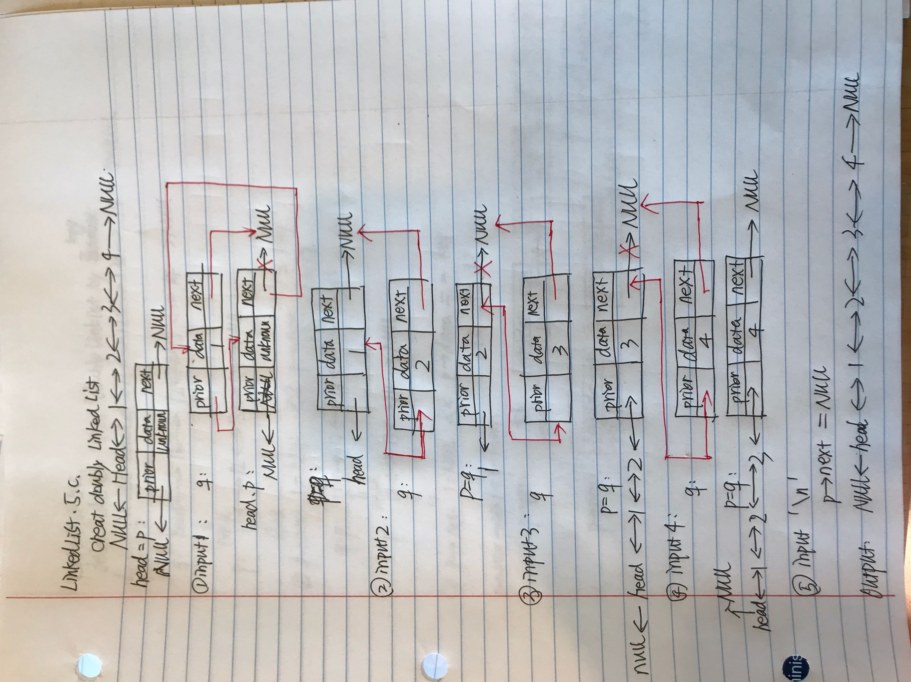

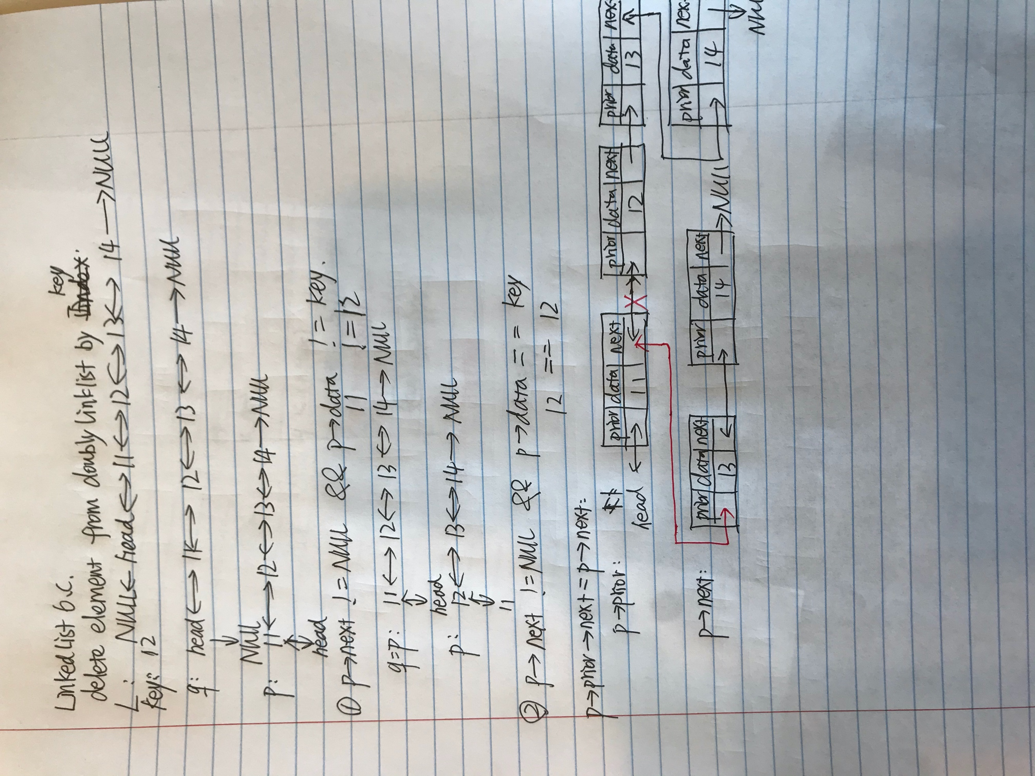

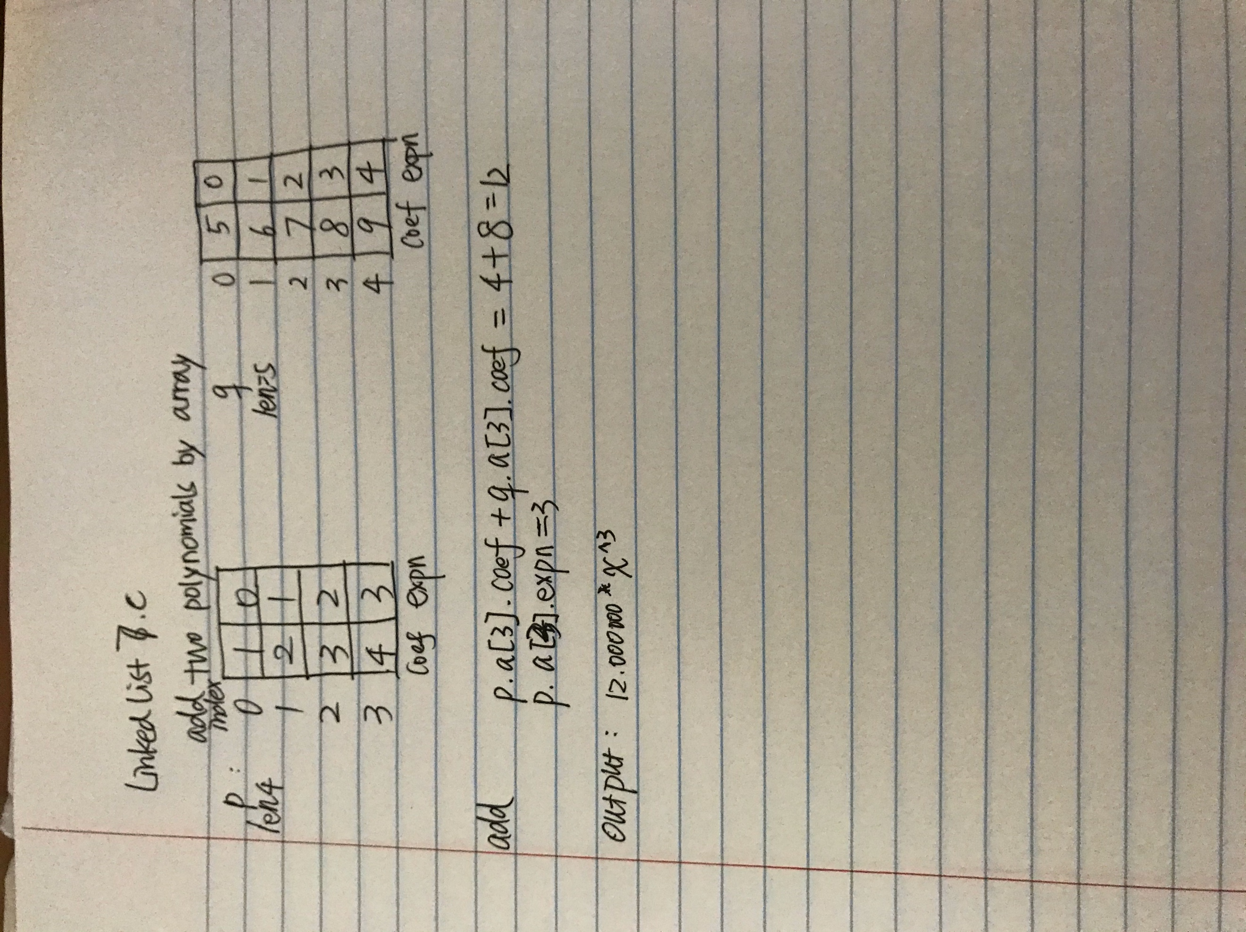

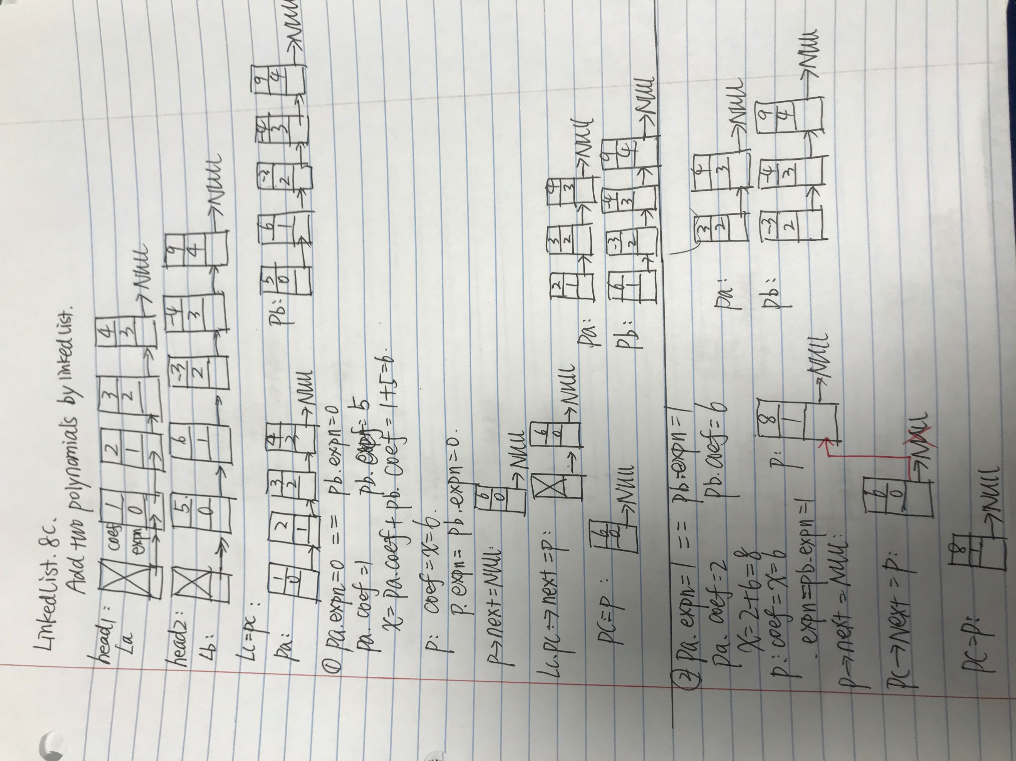

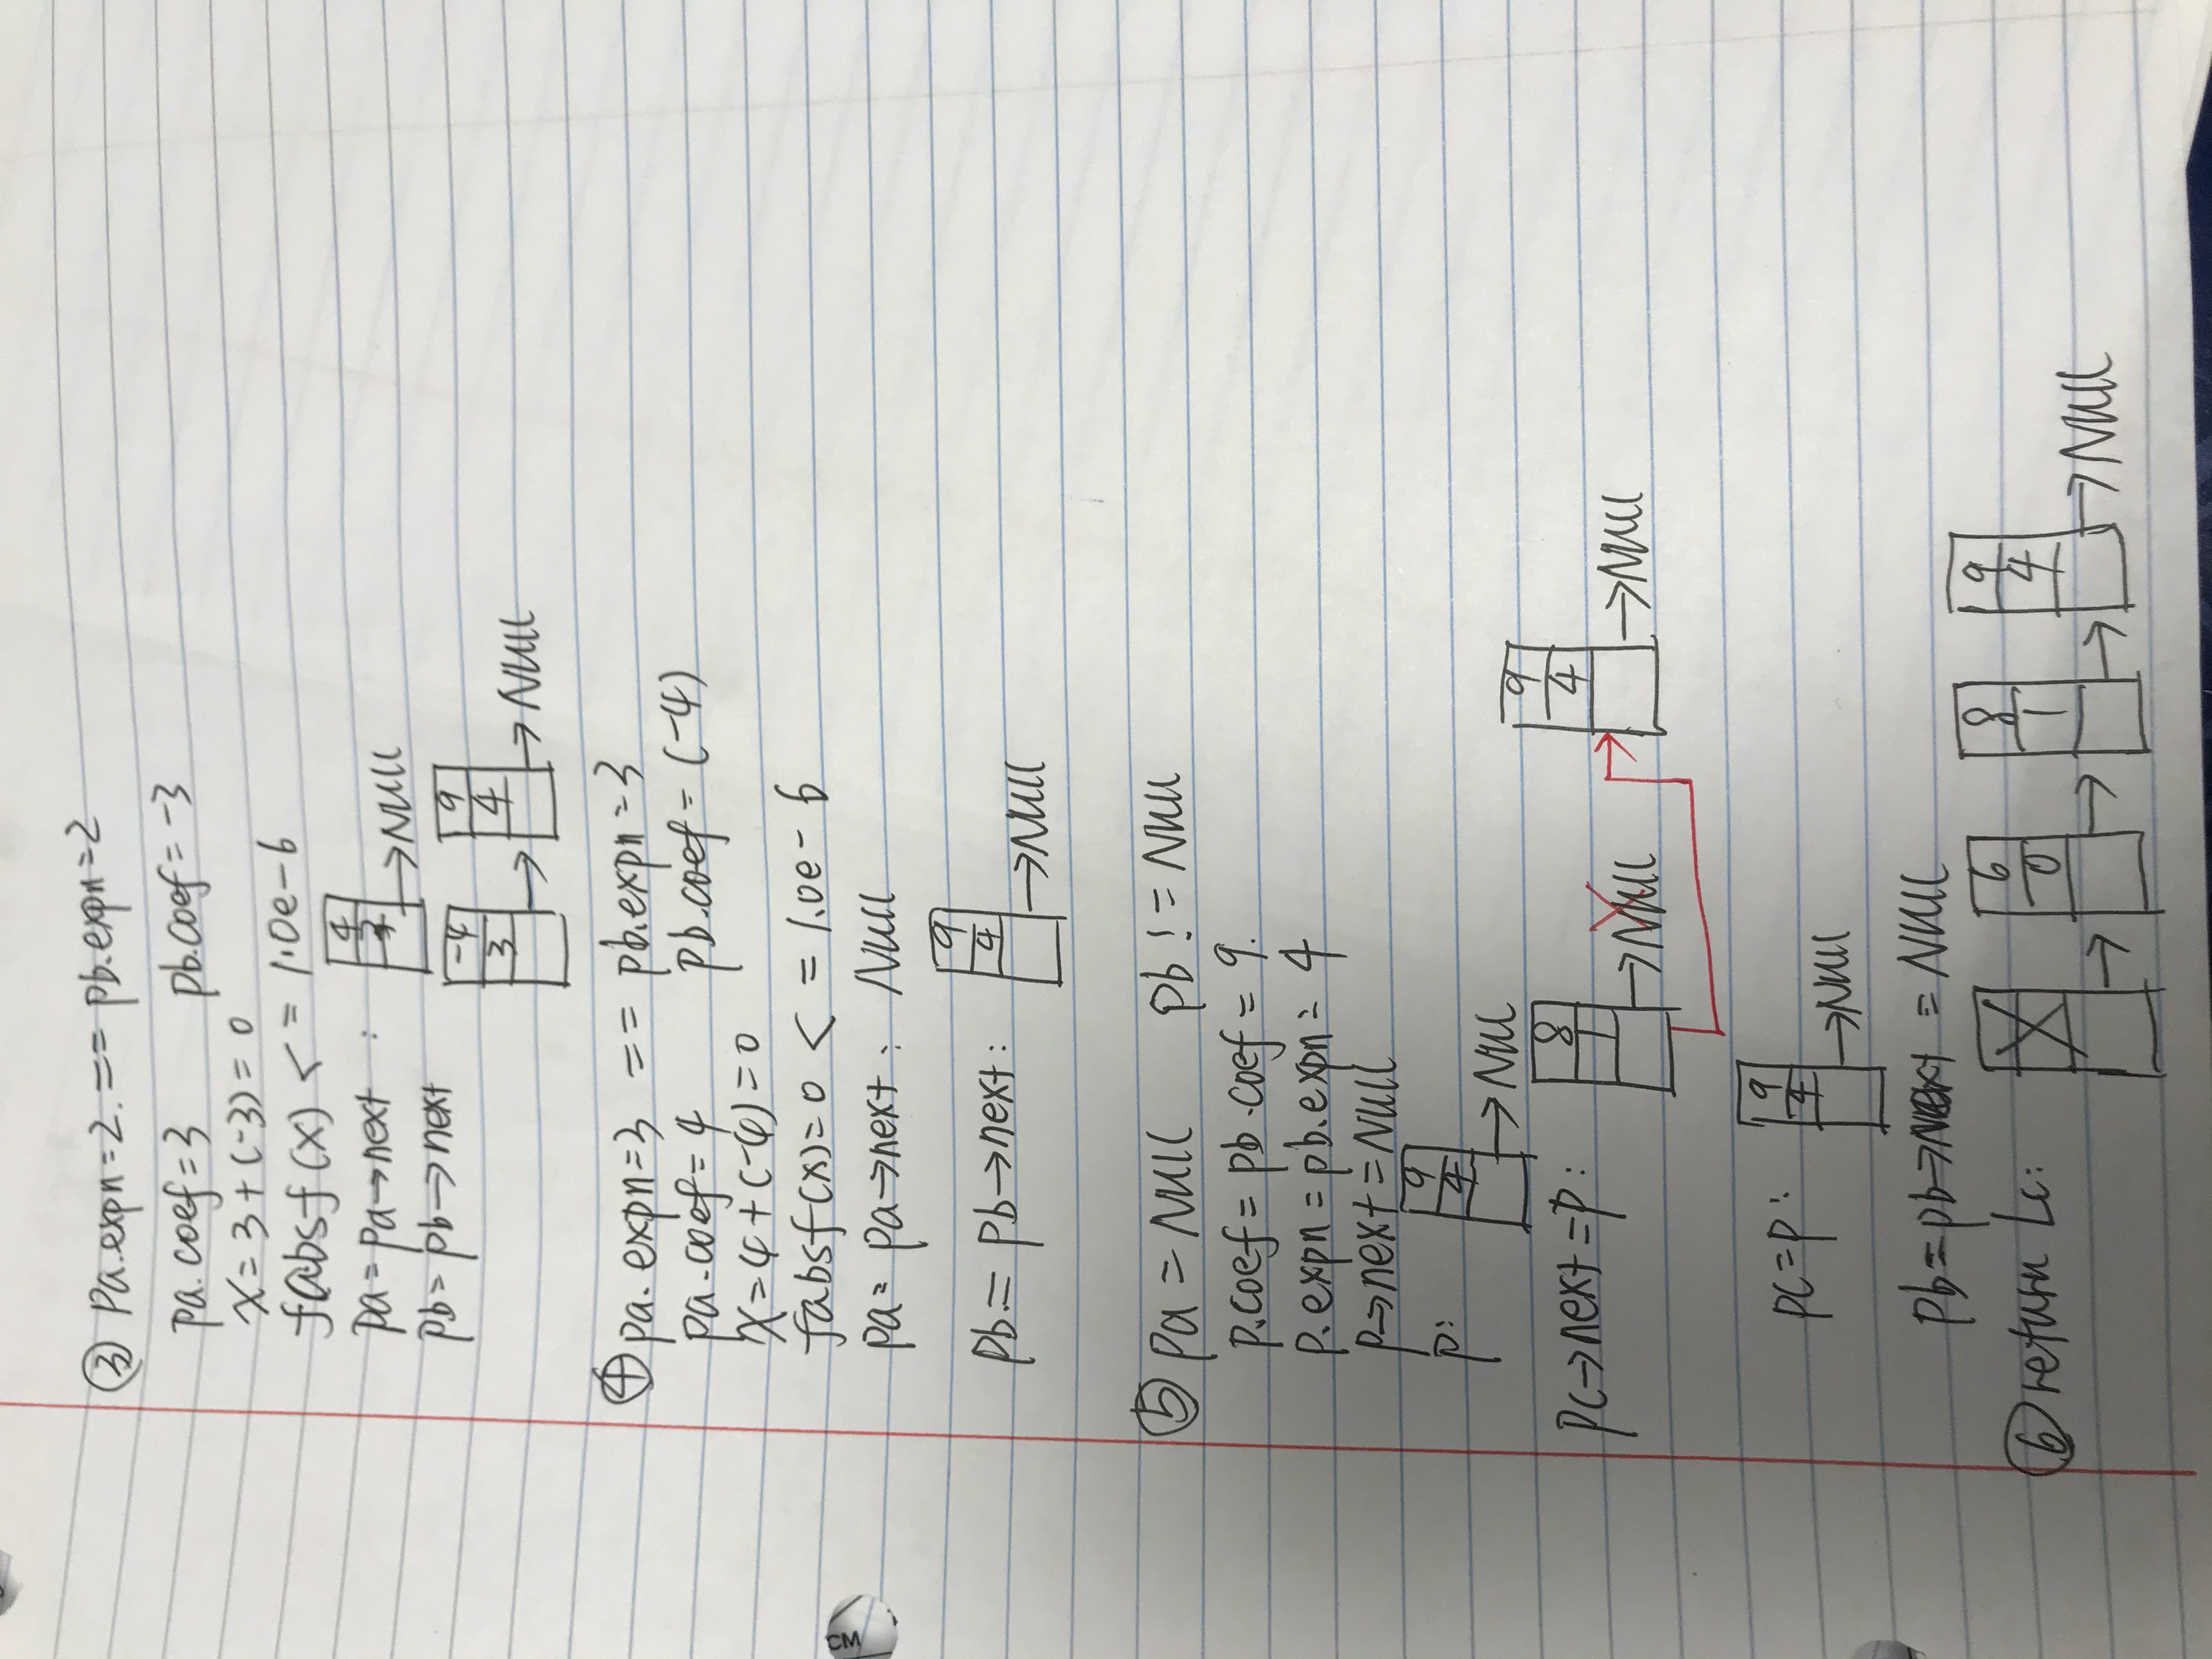

2. Create a function to insert an element by index to **circular** linked list. After that, verify it in main function. For instance, given circular linked list

*ls = Head->1->2->3->4->Head,* after calling function **cirLL_insert (ls, 1, 123)**, the new one will be *Head->1->123->2->3->4->Head*

Source code:

/*********************************************************************************************

* File Name: labhw#2-q2

* Author: Jingjing Tan

* Engineering School, NPU

* description: insert an element by index to circular linked list, such as

* Head->1->2->3->4->Head, then new linked list will be

* Head->1->123->2->3->4->Head

*********************************************************************************************/

#include <stdio.h>

#include <stdlib.h>

typedef int ElemType;

typedef struct Lnode

{

ElemType data;

struct Lnode *next;

}LNode;

LNode *circular_LinkList(void){

int data;

LNode *head, *p, *q;

head=p=(LNode *)malloc(sizeof(LNode));

head->next=NULL;

do{

scanf("%d",& data);

q= (LNode *)malloc(sizeof(LNode));

q->data=data;

q->next=p->next;

p->next=q;

p=q ;

}while(getchar()!='\n');

p->next = head;

return (head);

}

void cirLL_insert(LNode* list, int index, int value) {

int counter = 0;

LNode* cur = list;

while(counter < index && cur != NULL) {

cur = cur->next;

counter++;

}

if (cur == NULL) {

printf("Index out of range!\n");

} else {

LNode* newNode = (LNode *)malloc(sizeof(LNode));

LNode* next = cur->next;

newNode->next = next;

newNode->data = value;

cur->next = newNode;

}

}

void printList(LNode* list){

LNode *head;

head = list;

printf("Head");

while(1){

printf("=>");

list = list->next;

if(list->next == head) {

printf("%d=>Head\n", list->data);

break;

}

else

printf("%d",list->data);

}

}

int main(void) {

LNode *a, *b, *c;

a = circular_LinkList();

printList(a);

cirLL_insert(a, 1, 123);

printList(a);

return 0;

}

Output:

1 2 3 4 5

Head=>1=>2=>3=>4=>5=>Head

Head=>1=>123=>2=>3=>4=>5=>Head

3. Write a program to create a **circular doubly** linked list for a given open one, such as *l= NULL<-Head<=>1<=>2<=>3<=>4->NULL,* by calling **cirDul_LL(l),** you will get *Head<=>1<=>2<=>3<=>4<=>Head*

Sourcecode:

/*********************************************************************************************

* File Name: labhw#2-q3

* Author: Jingjing Tan

* Engineering School, NPU

* description: create a circular doubly linked list for a given open one, such as

* Head<=>1<=>2<=>3<=>4->NULL, then new linked list will be

* Head<=>1<=>2<=>3<=>4<=>Head

*********************************************************************************************/

#include <stdio.h>

#include <stdlib.h>

typedef int ElemType;

typedef struct Lnode

{

ElemType data;

struct Lnode *prev;

struct Lnode *next;

}LNode;

LNode *create_LinkList(void){

int data;

LNode *head, *p, *q;

head=p=(LNode *)malloc(sizeof(LNode));

head->prev=NULL;

head->next=NULL;

do{

scanf("%d",& data);

q= (LNode *)malloc(sizeof(LNode));

q->data=data;

q->prev = p;

q->next=p->next;

p->next=q;

p=q ;

}while(getchar()!='\n');

return (head);

}

void cirDul_LL(LNode* list) {

LNode* tail = list->next;

while (tail->next != NULL) {

tail = tail->next;

}

list->prev = tail;

tail->next = list;

}

void printList(LNode* list){

LNode* head = list;

if (head->prev == NULL) {

printf("NULL<=Head");

} else {

printf("Head");

}

while(1){

printf("<=>");

list = list->next;

if (list->next == head) {

printf("%d<=>Head\n", list->data);

break;

} else if(list->next == NULL) {

printf("%d=>NULL\n", list->data);

break;

}

else

printf("%d",list->data);

}

}

int main(void) {

LNode *a;

a = create_LinkList();

printList(a);

cirDul_LL(a);

printList(a);

return 0;

}

Output:

1 2 3 4

NULL<=Head<=>1<=>2<=>3<=>4=>NULL

Head<=>1<=>2<=>3<=>4<=>Head

4. Generate a function to insert an element by index to **doubly** linked list. If existing list is like *lst= NULL<-Head<=>1<=>2<=>3<=>4->NULL,* result should be *NULL<-Head<=>1<=>123<=>2<=>3<=>4->NULL* through

**dul_LL_insert (lst, 1, 123)** function call

Sourcecode:

/*********************************************************************************************

* File Name: labhw#2-q4

* Author: Jingjing Tan

* Engineering School, NPU

* description: insert an element by index to doubly linked list, such as

* lst= NULL<-Head<=>1<=>2<=>3<=>4->NULL, then new linked list

* will be like: Head<=>1<=>123<=>2<=>3<=>4->NULL

*********************************************************************************************/

#include <stdio.h>

#include <stdlib.h>

typedef int ElemType;

typedef struct Lnode

{

ElemType data;

struct Lnode *prev;

struct Lnode *next;

}LNode;

LNode *create_LinkList(void){

int data;

LNode *head, *p, *q;

head=p=(LNode *)malloc(sizeof(LNode));

head->prev=NULL;

head->next=NULL;

do{

scanf("%d",& data);

q= (LNode *)malloc(sizeof(LNode));

q->data=data;

q->prev = p;

q->next=p->next;

p->next=q;

p=q ;

}while(getchar()!='\n');

return (head);

}

void dul_LL_insert (LNode* list, int index, int value) {

int counter = 0;

LNode* cur = list;

while(counter < index && cur != NULL) {

cur = cur->next;

counter++;

}

if (cur == NULL) {

printf("Index out of range!\n");

} else {

LNode* newNode = (LNode *)malloc(sizeof(LNode));

LNode* next = cur->next;

newNode->next = next;

newNode->data = value;

cur->next = newNode;

}

}

void printList(LNode* list){

LNode* head = list;

if (head->prev == NULL) {

printf("NULL<=Head");

} else {

printf("Head");

}

while(1){

printf("<=>");

list = list->next;

if (list->next == head) {

printf("%d<=>Head\n", list->data);

break;

} else if(list->next == NULL) {

printf("%d=>NULL\n", list->data);

break;

}

else

printf("%d",list->data);

}

}

int main(void) {

LNode *a;

a = create_LinkList();

printList(a);

dul_LL_insert(a, 1, 123);

printList(a);

return 0;

}

Output:

1 2 3 4

NULL<=Head<=>1<=>2<=>3<=>4=>NULL

NULL<=Head<=>1<=>123<=>2<=>3<=>4=>NULL